EMPLOYEE MANAGEMENT : REST API ASSIGNMENT 6 SOLUTION

1. Add Roles Dynamically

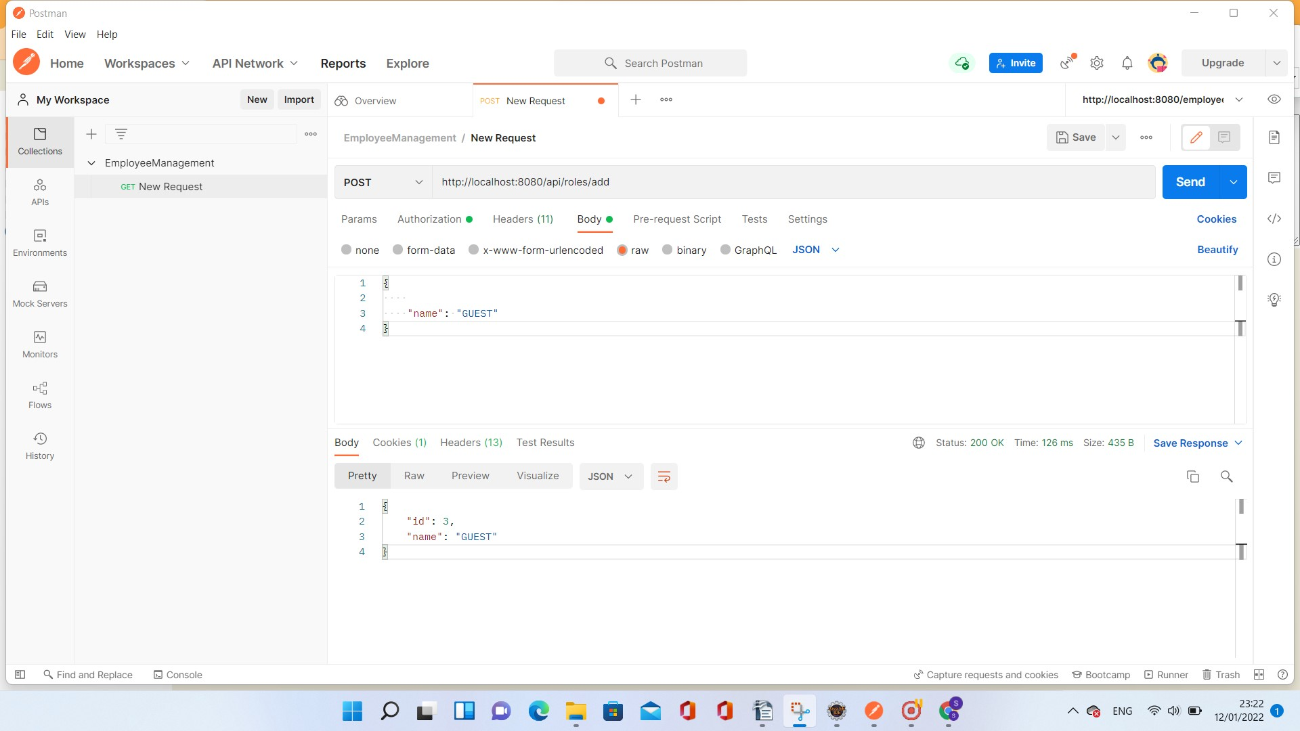

Roles List Before Adding

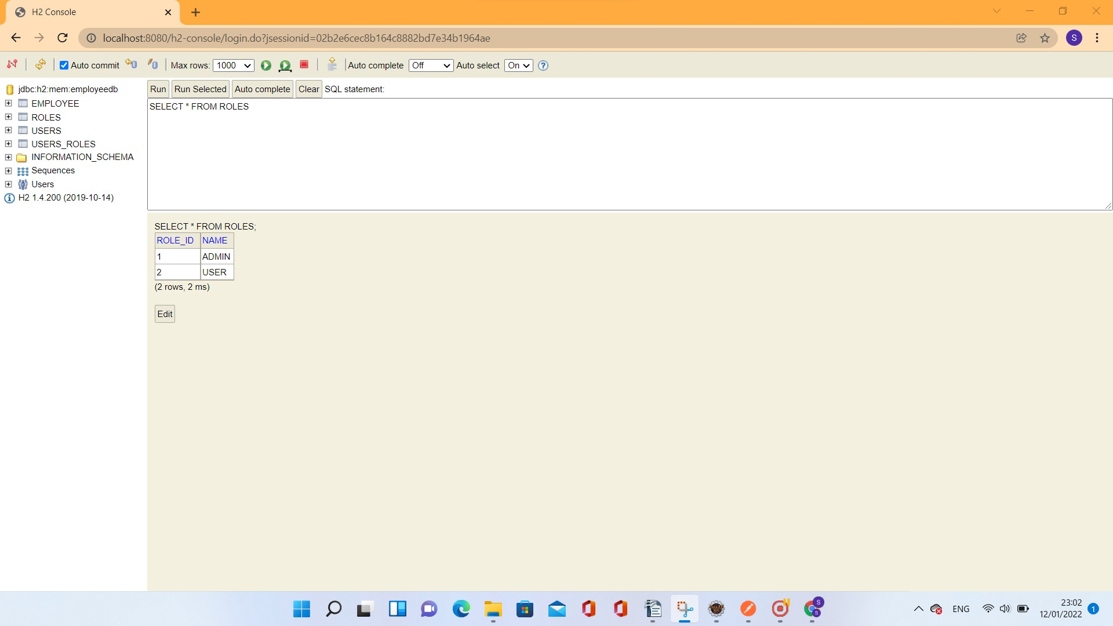

Roles List After Adding

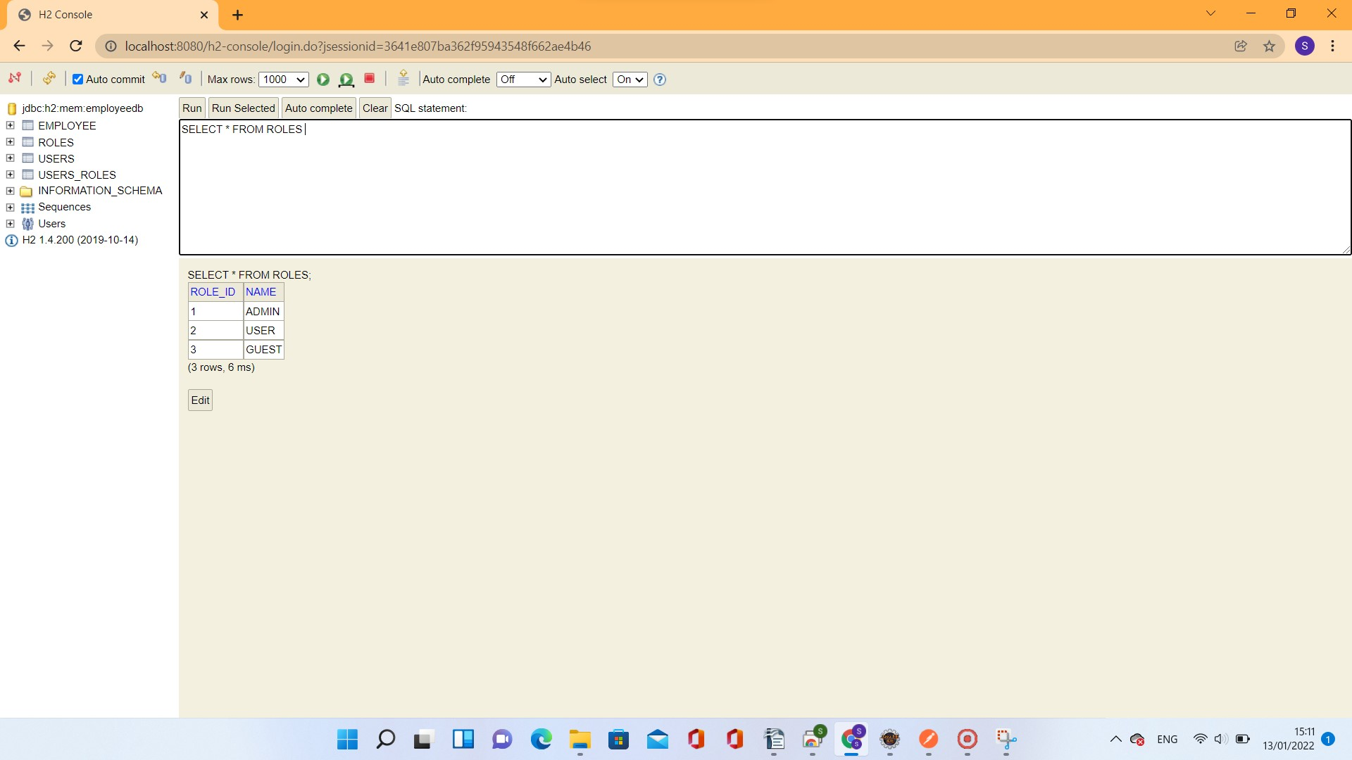

2. Add Users to the DB

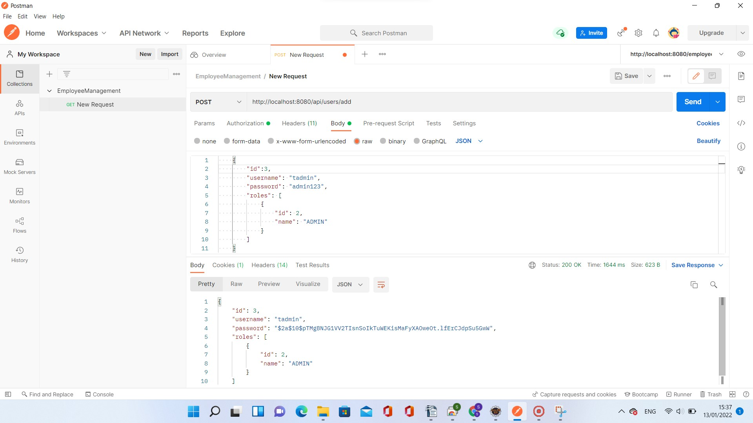

Users List Before adding tadmin

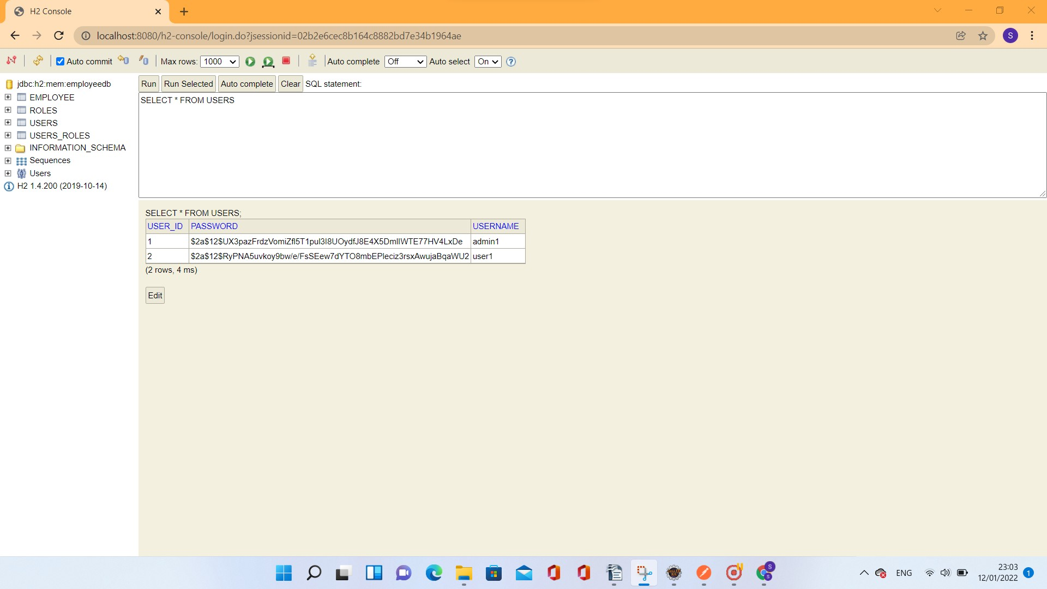

Users List after adding the tadmin

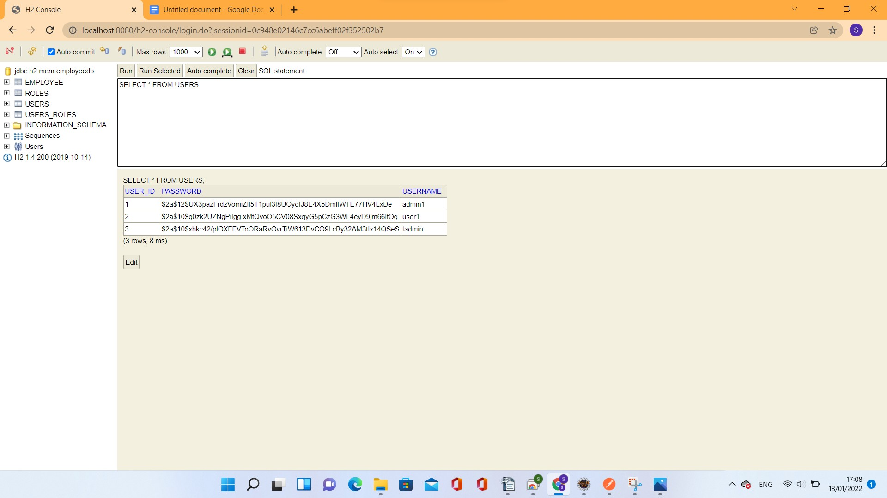

3. Add Employees Data

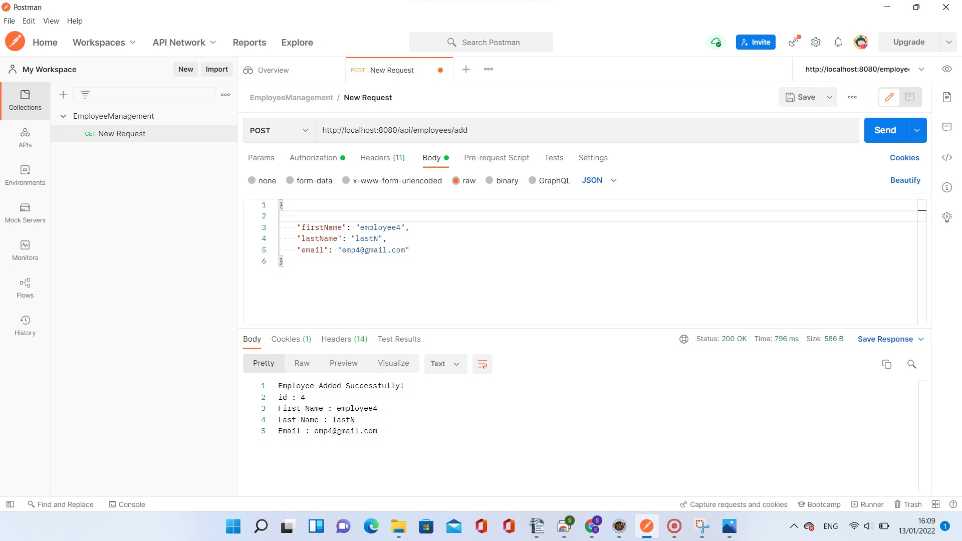

4. Employees List

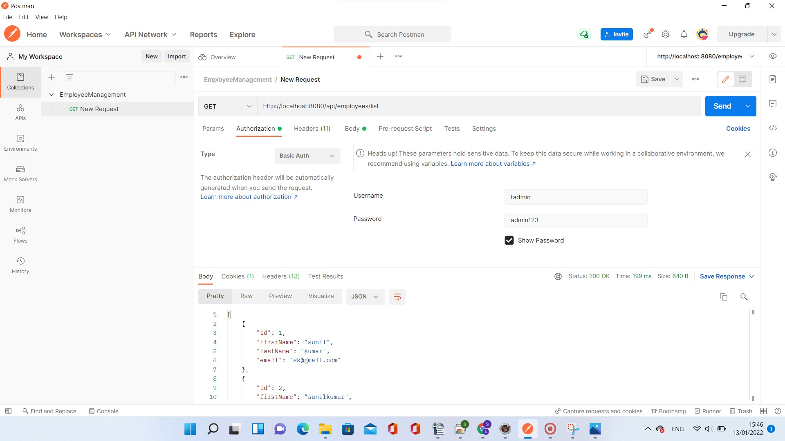

Employees List from H2 Console

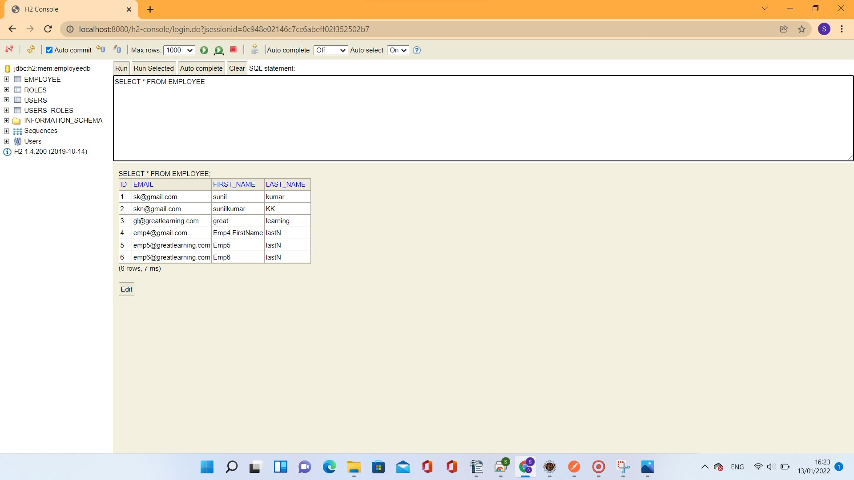

5. Fetch Employee Record for the given Id

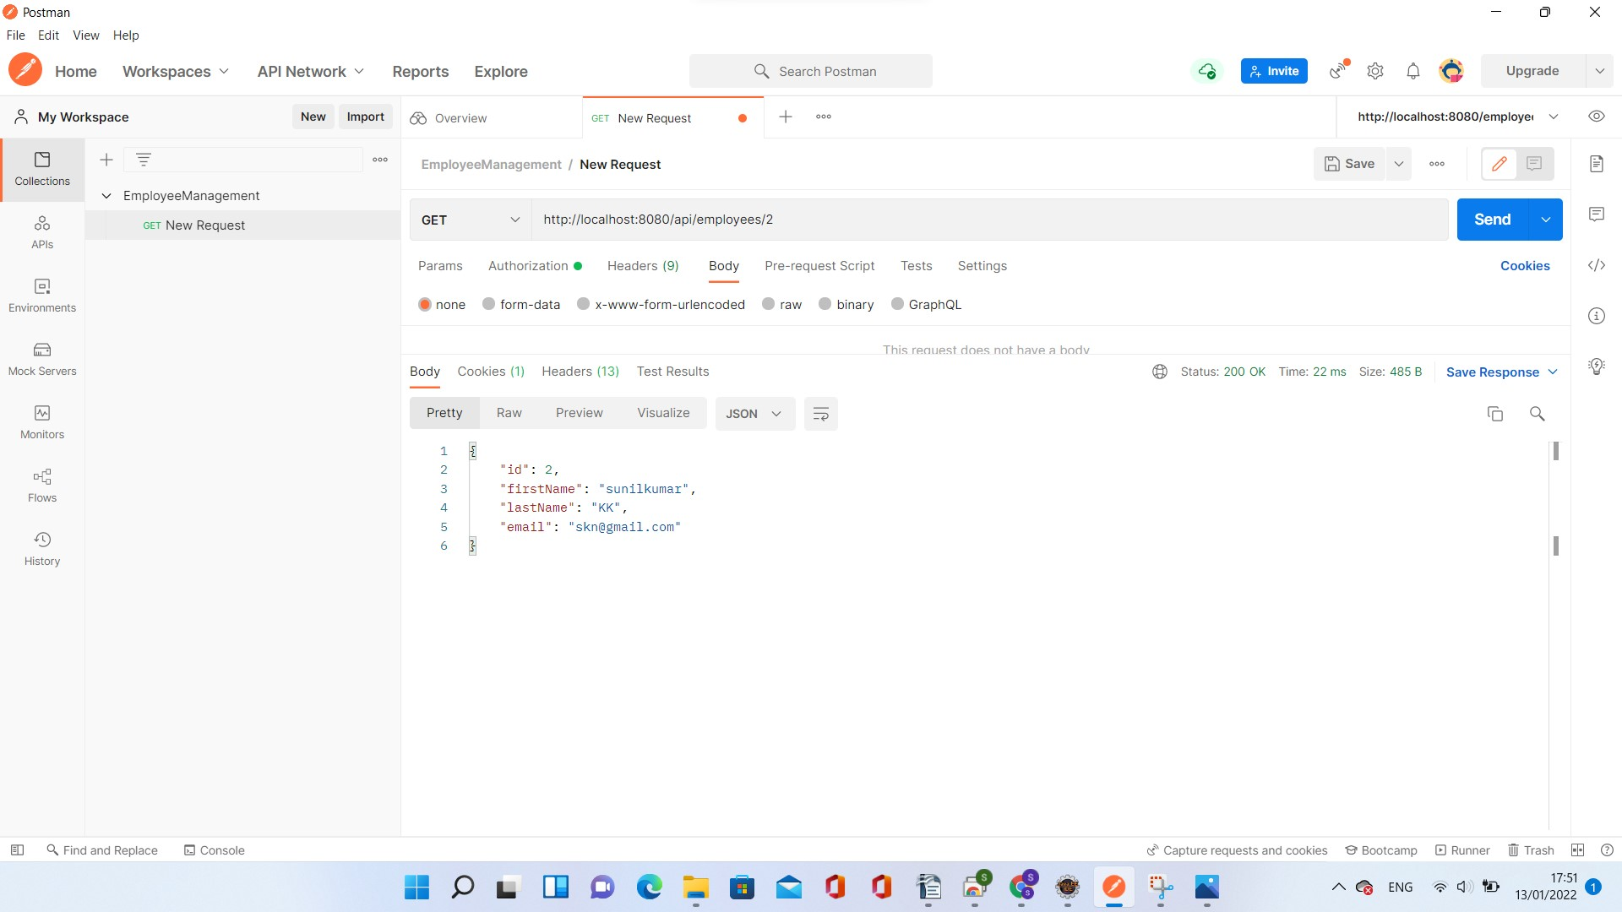

6. Update and existing Employee

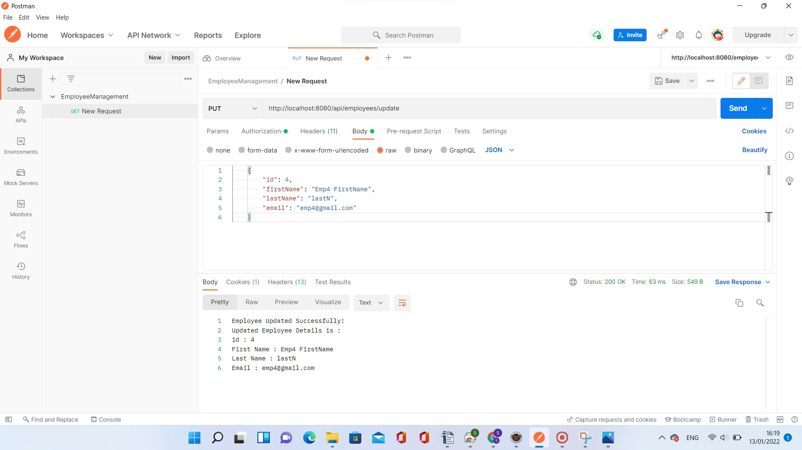

Updated Employee List in H2 - Console

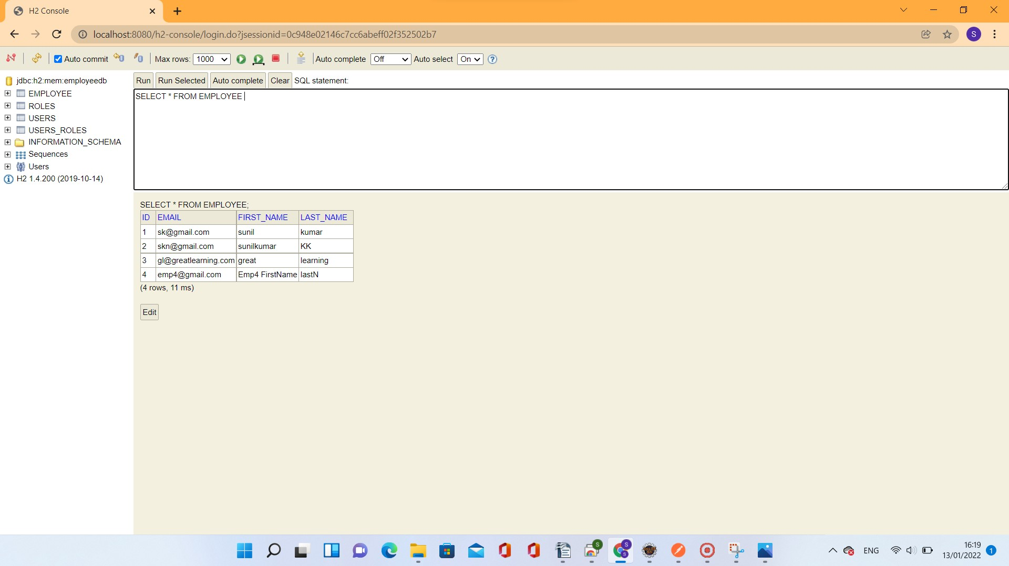

7. Delete an Employee Record by giving id

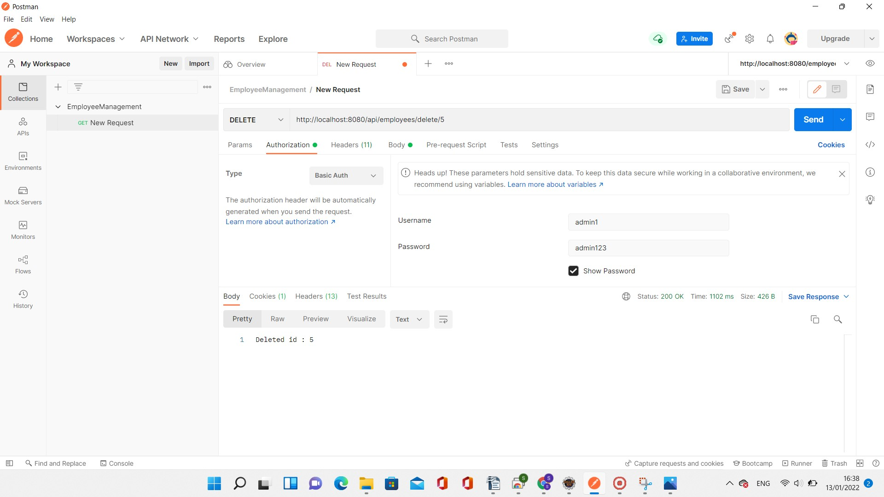

Delete Record Not permitted for user1

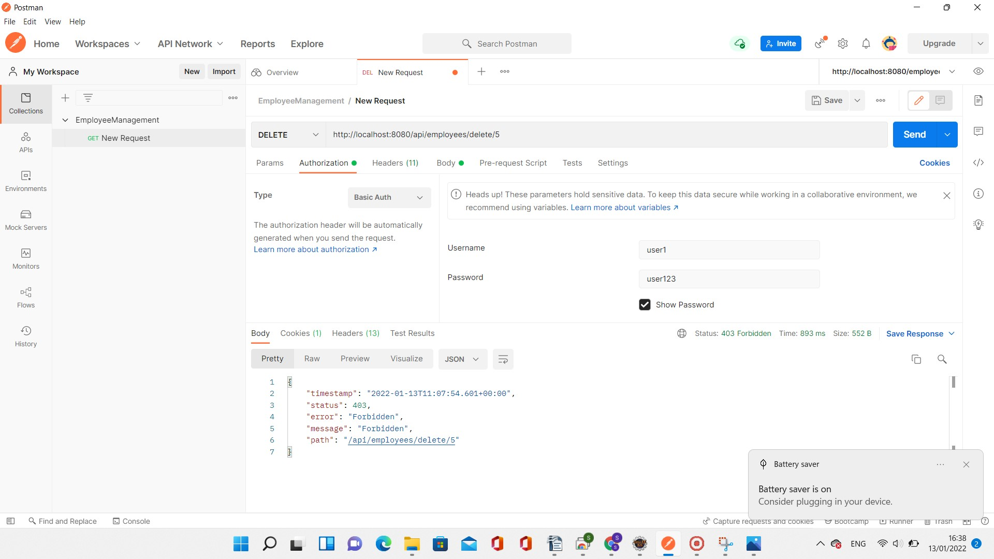

Employees List H2 Console after the deletion of Employee Record 5

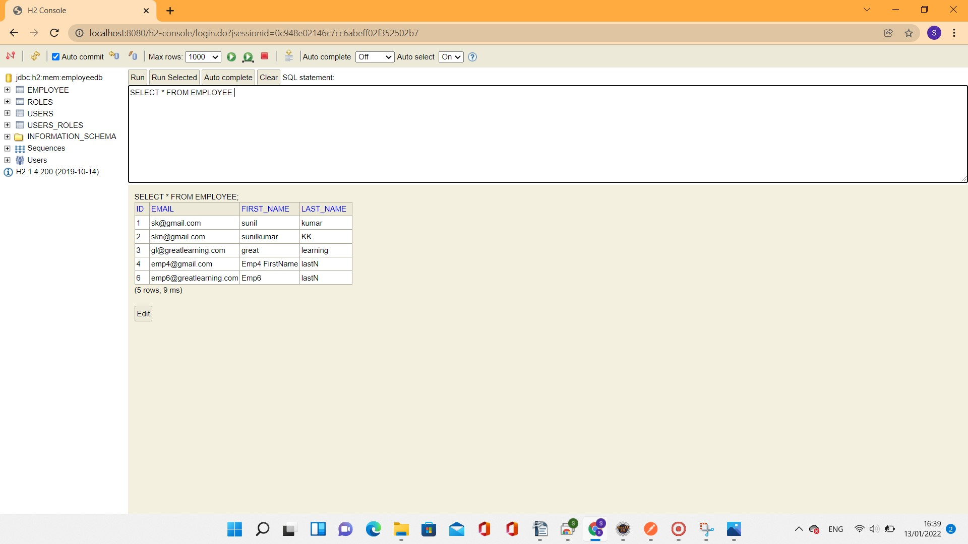

8. Fetch Employees by Search on First Name

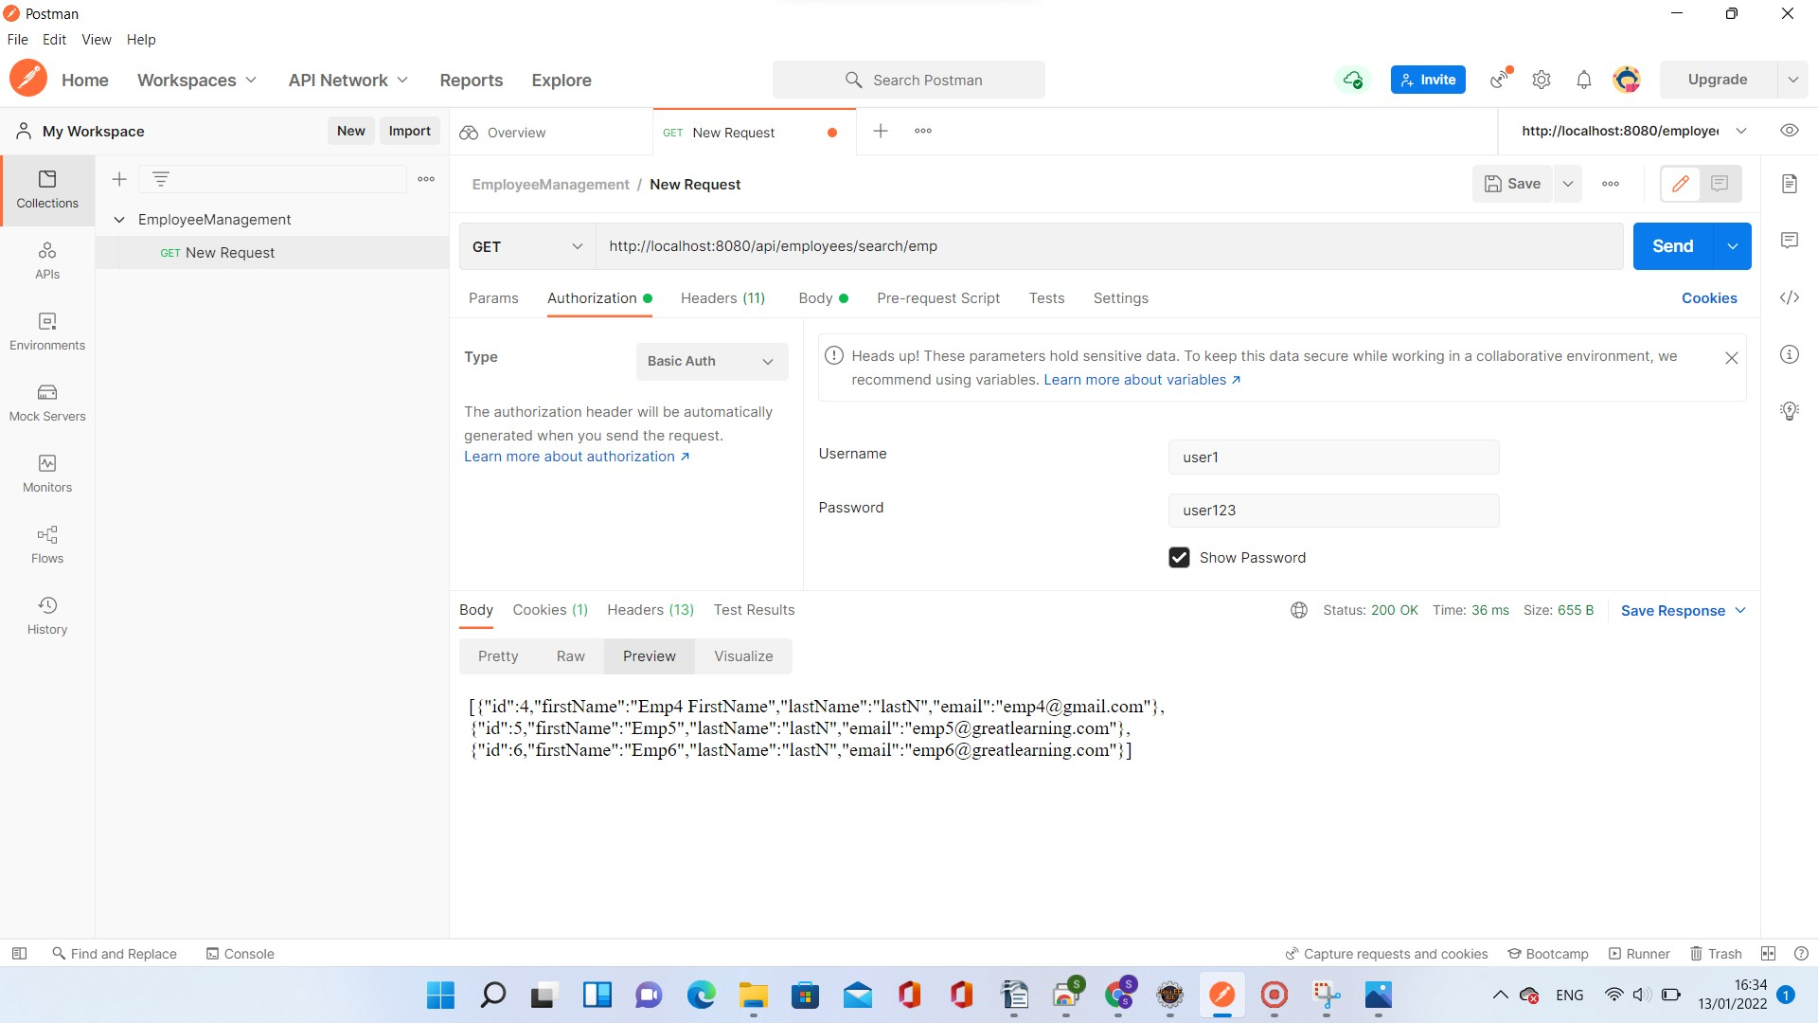

9. Employees Sort on First Name

Sort Order - Ascending

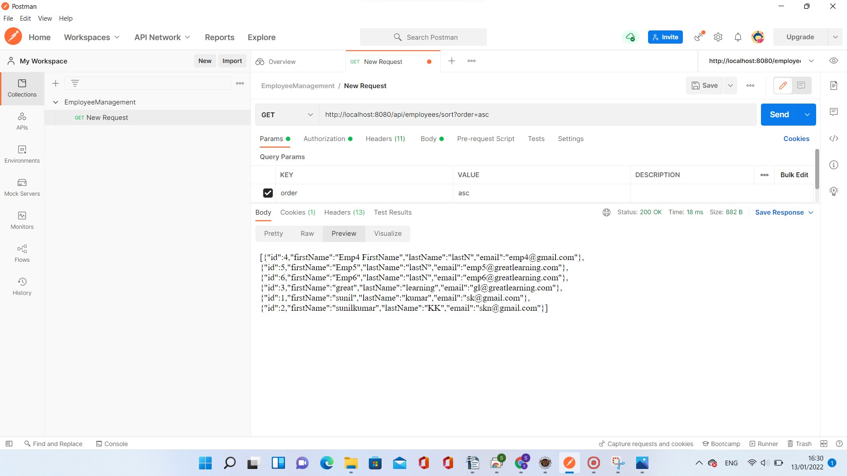

Sort Order - Descending

